Traveling to South Bend via Public Transport from Chicago Airports
If you are flying into a Chicago airport to attend the ZRA Conference, this guide will walk you through travelling to South Bend via public transportation from both O’Hare and Midway Airports.
Whichever airport you use, the South Shore Line commuter train is a convenient option to get from downtown Chicago to South Bend. South Shore Line trains depart several times daily from Chicago’s Millennium Station on Michigan Avenue, across the street from Millennium Park and “The Bean.” Millennium Station is walking distance from many attractions, including the Magnificent Mile and the Art Institute of Chicago.
From O’Hare Airport (ORD):
Follow signs reading Trains to City-CTA to the O’Hare Blue Line terminal. Purchase a Ventra Card from the vending machines at the station, head through the turnstiles and down the escalator to the platform. Board whichever train is indicated to be leaving first (this is the last stop so the trains only go one direction.) The ride should take 35-40 minutes. Plan a trip / Get transit directions - CTA (transitchicago.com)
Take the train to the Washington stop. Before you exit the station, check the signs to exist East toward Randolph Street. Head up to the street (this line runs underground through downtown) and head east on Randolph Street to Millennium Station, where you can board the South Shore Line to South Bend. This is a very detailed guide to taking the Blue Line from O’Hare to Millennium Park and includes some sightseeing tips: A complete guide from O’Hare to Millennium Park via public transit - Curbed Chicago

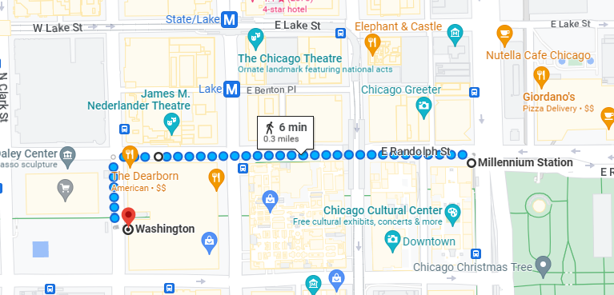
From Midway Airport (MDW)
Follow signs reading Trains to City-CTA to the Midway Orange Line station. Purchase a Ventra card at one of the vending machines in order to board. Midway is the last stop so trains only run one way. Elevated trains (the El) take about 20-25 minutes to reach the Loop (which is actually the circular el track that gives this part of downtown its name). Enjoy the view and then hop off at Washington and Wabash, walk one block east to Michigan Ave. and one block north to Millennium Station: Plan a trip / Get transit directions - CTA (transitchicago.com)

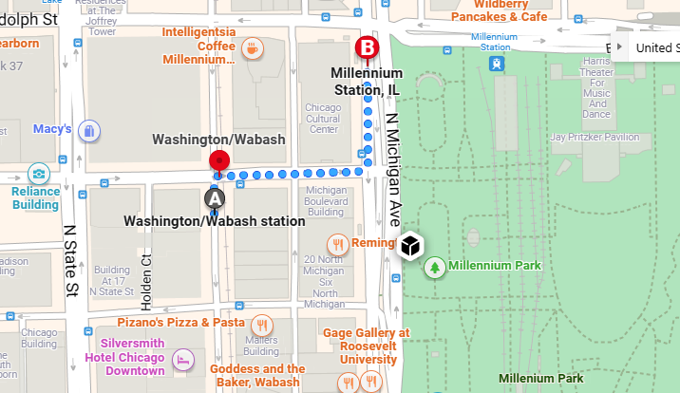

The South Shore Line
Inside Millennium Station, follow signs to the South Shore Line. Trains run every few hours from early morning to late evening. There are restaurants in Millennium Station and you can take food and drinks on the train. Travel time from Chicago to the South Bend Airport is about 2 hours 45 minutes. The South Bend Airport has taxis, Uber and Lyft available. Note that Chicago times are Central and South Bend is Eastern. A one way ride costs about $15. Tickets can be purchased at the station or via the app. Home (mysouthshoreline.com)

